Week 1: Project Planning & Azure Setup (6–12 March)
Business Requirements for CTU Training Solutions
- CTU Training Solutions provides IT training courses online.
- Students must be able to access labs and resources remotely.
- Student progress and results should be stored securely.
- Instructors must manage courses, assignments, and student access efficiently.
- Resources must be scalable based on the number of students using them.

Required Azure Services
Business Requirement | Azure Service Needed
Store student data securely | Azure SQL Database
Host online labs / virtual machines | Azure Virtual Machines / Azure Lab Services
Manage users, roles, and access | Azure Active Directory + RBAC
Monitor usage and progress | Azure Monitor / Power BI
Tag and organize resources for easy management | Azure Resource Groups and Tags

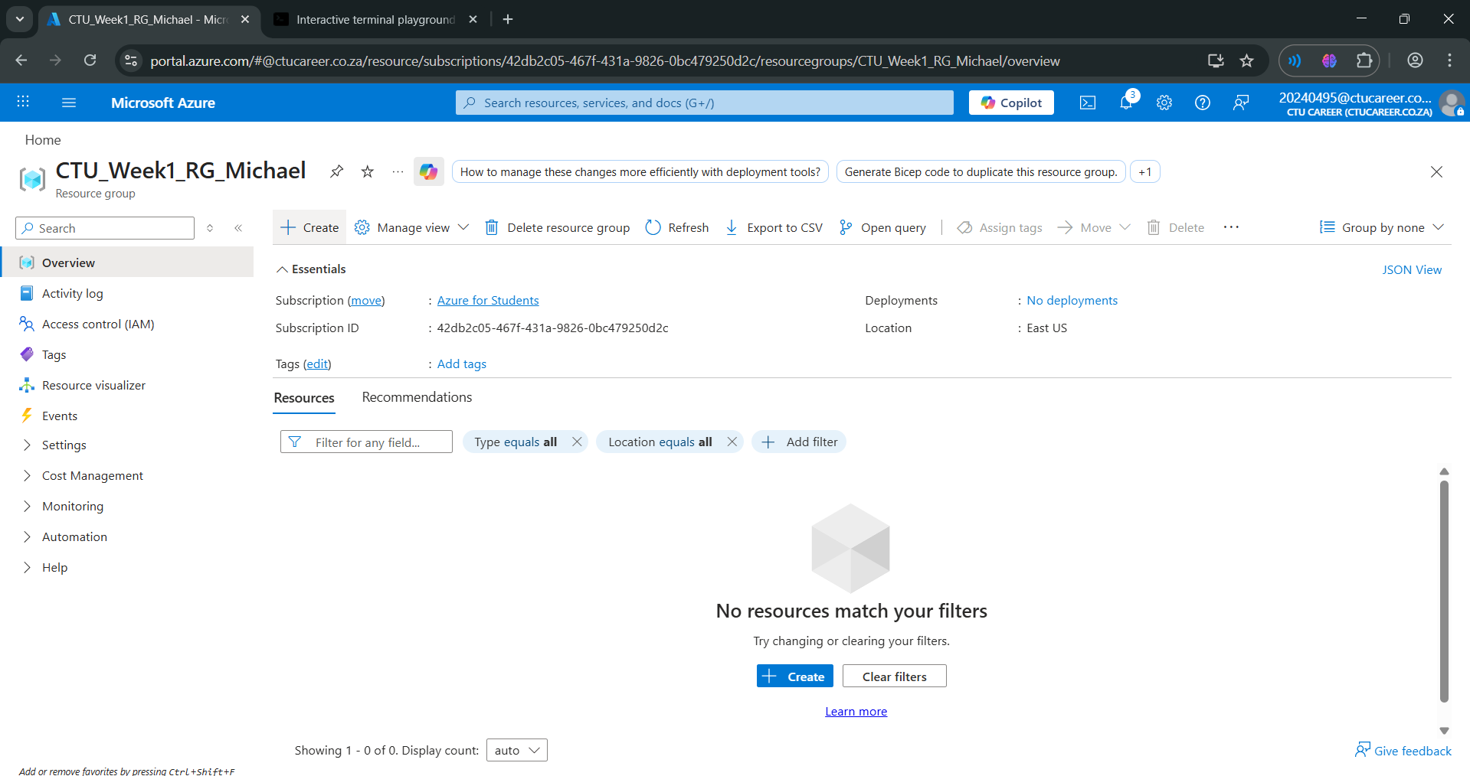
Figure 1:The resource group CTU_Week1_RG_Michael has been created in the East US region. Tags were added for Course (NET731-LABS), Week (1), and Owner (Michael). This resource group will host student lab resources and Azure services required for Week 1 activities

